## Iteration 0 individual challenge (energy usage prediction)

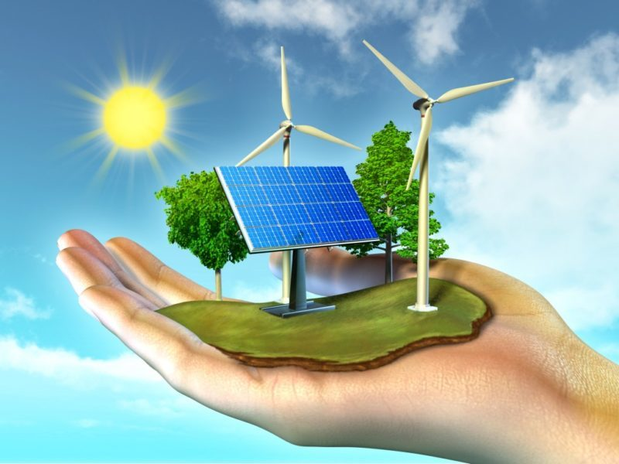

Name: Matthijs Dolmans

Version: 0.1

Inhoudsopgave

Iteration 0 individual challenge (energy usage prediction) 1

Challenge explanation 2

Domain understanding 2

Provisioning 4

Sources 5

## Challenge explanation

For this challenge I want to predict the energy usage of households

# Domain understanding

Why predict energy usage in households

predicting household energy usage can be used to accurately predict and estimate the energy consumption patterns of a household. This predictive model aims to provide insights into when and how much energy a household is likely to use based on various factors. With this households can optimize their energy consumption, thereby contributing to energy efficiency, and cost savings.

What is energy in households

Energy exists in a lot of different forms. In households there are 2 main energy forms which are Electricity and natural gas. If we look at what electricity is and what it is used for the most. These electrical devices in households are mostly responsible for the electricity usage:

- Refrigerator / freezer (18%)

- Dishwasher

- Washing machine

- washer-dryer (6%)

- cooking

- lighti

What factors have impact on energy usage in households

1. household size

2. house size

3. weather conditions

4. solar panels

5. energy label

6. house type

7. house build year

All homes in The Netherlands have an energy label. This label gives you an indication how energy efficient a property is compared to a similar property. The labels range from A++++ to G, where A to C is generally considered energy efficient and D to G not so.

In 2015 every house in the Netherlands received an indication.

10 factors labels are based on

- Type of house.

- Size of the house.

- Construction year.

- Kind of glass. Are there single-glass, double-glass or even triple-glass panels?

- Facade insulation.

- Roof insulation.

- The kind of heating system which is used.

- Separate heating system for hot water (not the kitchen boiler).

- Ventilation system

- Solar panels and solar boiler.

[1]

Interview

Energy exists out of different forms should I keep focussing on energy or take 1 form of energy?

Which country data should I use?

## Provisioning

Data gathering

After getting some domain understanding I looked at a lot of different datasets

<https://www.eia.gov/consumption/residential/data/2020/#fueluses>

<https://zenodo.org/record/6778401>

<https://opendata.cbs.nl/statline/#/CBS/nl/dataset/83882NED/table?dl=3FD72>

<https://opendata.cbs.nl/statline/#/CBS/nl/dataset/81528NED/table?ts=1695216315025>

All these databases had some information but not exactly what I was looking at in the first place eventually I found a database that had some information I wanted which I started with

<https://opendata.cbs.nl/statline/portal.html?_la=nl&_catalog=CBS&tableId=85140NED&_theme=125>

Data requirements

|  |  |  |  |
| --- | --- | --- | --- |
| Name | Data type | Units | Range |
| Household size | numerical | persons | 2-9 [2] |
| House size | numerical | m² |  |
| weather conditions | numerical | degrees | -18 / 42 [3] |
| Solar panel | Time series | kwh |  |
| energy label | categorical | A++, A+, A, B, C, D, E, F, G | A / G [1] |
| house type | categorical |  |  |
| House build year | numerical | years |  |

**Determine data volume**

**Define data quality standards**

**Consider ethical and legal aspects**

All the data used is going to be not linked to any person, and all the data will be publicly available.

## Sources

[1] <https://settledownsupport.nl/house-energy-label/>

[2][ranges of people in households](https://www.un.org/en/development/desa/population/publications/pdf/popfacts/PopFacts_2017-2.pdf)

[3] [max/min temperaturen in Nederland](https://nl.wikipedia.org/wiki/Lijst_van_weerrecords)